Installation Instructions for Process West intercooler kit 2020+ Toyota GR Yaris
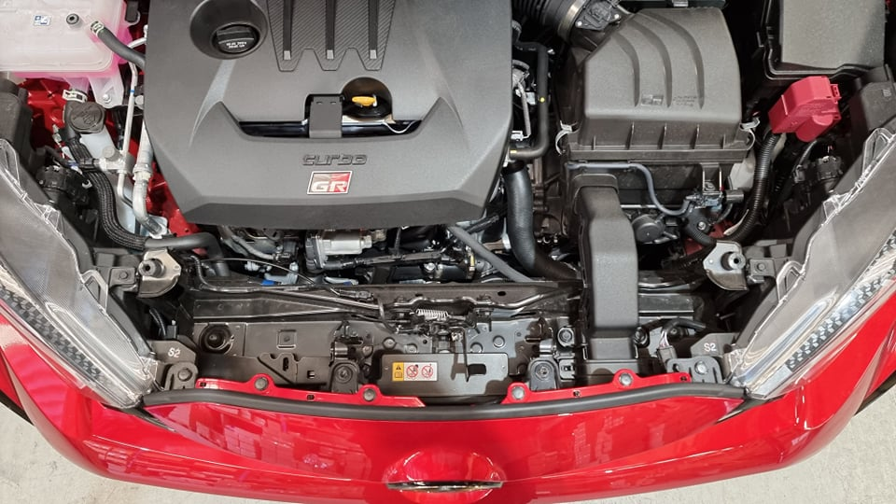

Remove 2 x bolts and 2 x clips

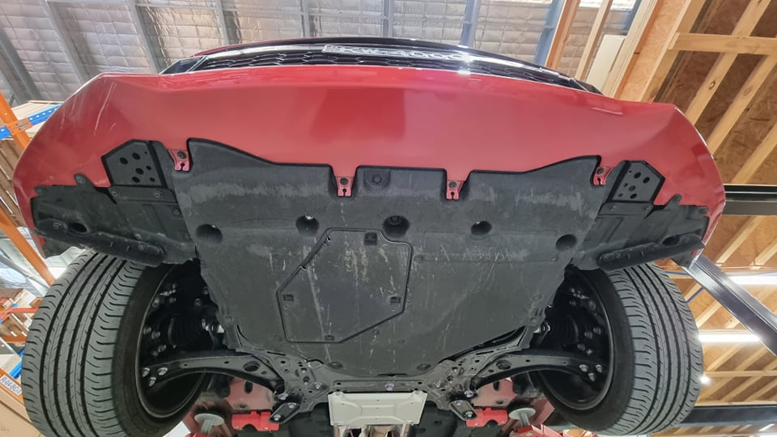
remove bolts and clips

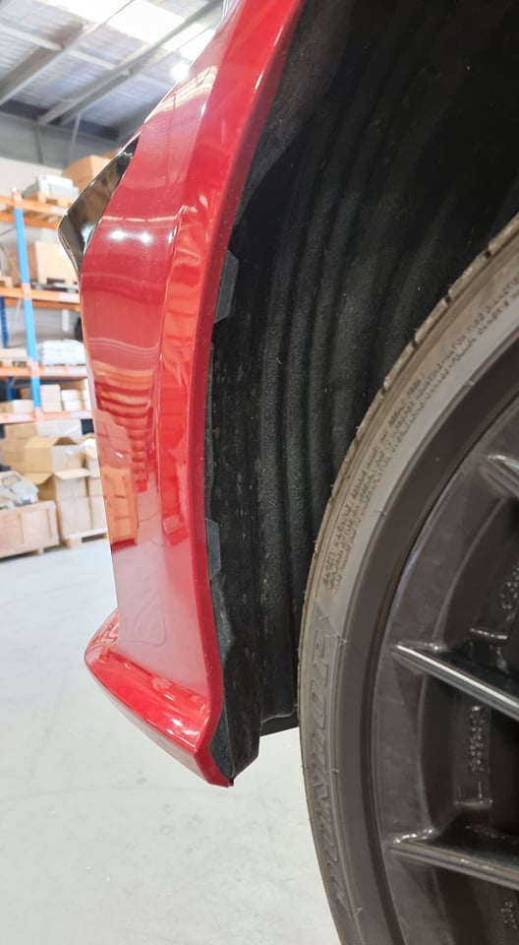
remove 2 x clips each side of vehicle

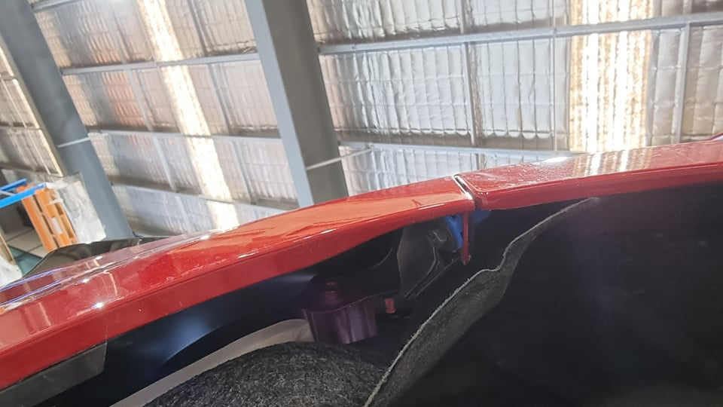
Remove 10mm bolt and plastic clip
each side of vehicle

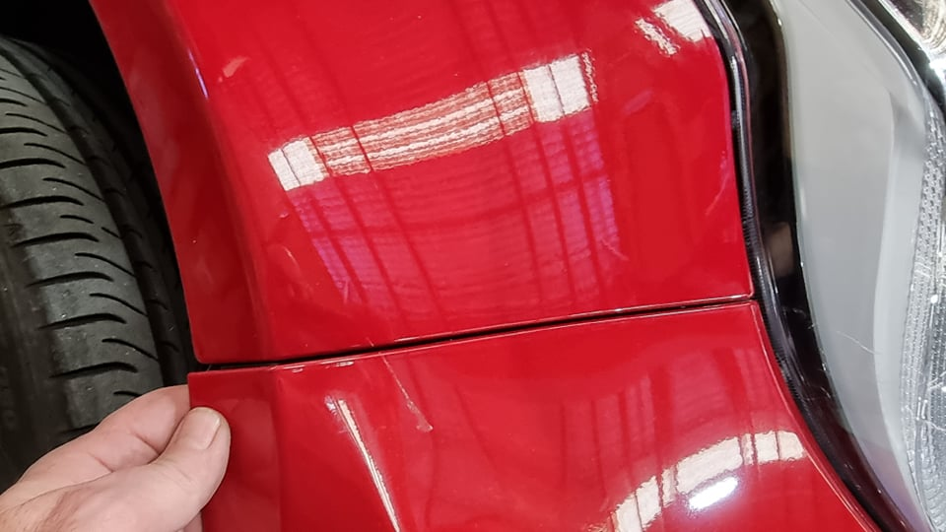

Gently pull bumper to release corner clip

There are two more clips to release on each side of the bumper. The below pics shows after the bumper had been removed to show what is underneath. Gently pull the bumper bar down and insert and trim removal tool (or similair) and push the clip in the direction of the arrow while pulling on the bar…it will eventually pop.
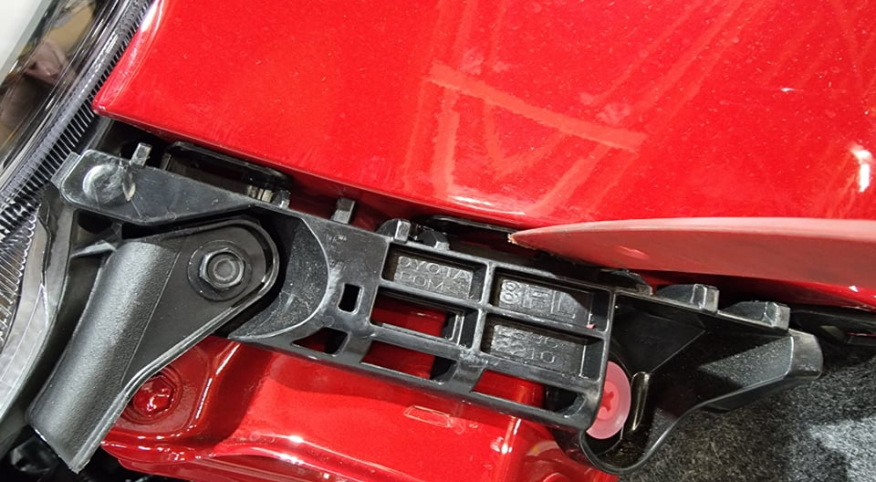

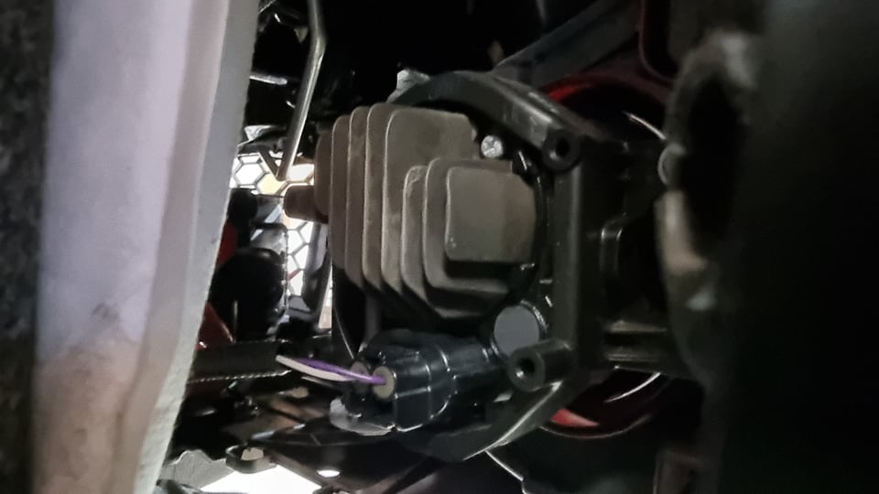
Unplug fog lights on each side

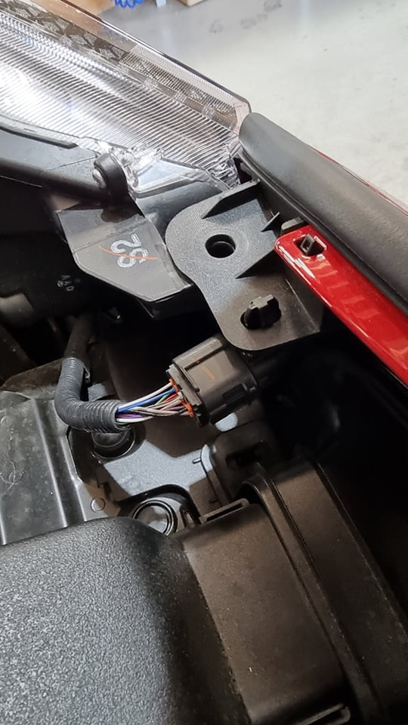
Unclip and unplug electrical connection

Remove bar

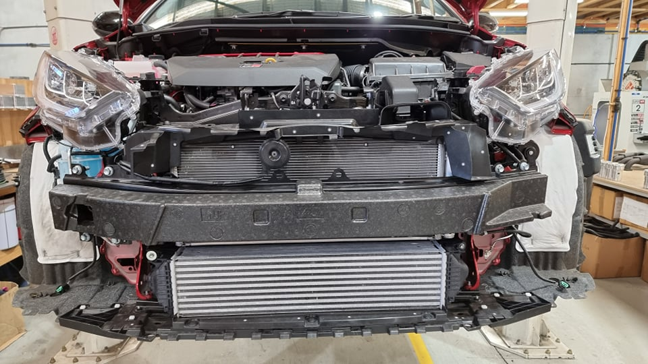

Remove crash bar foam
crash bar and intercooler

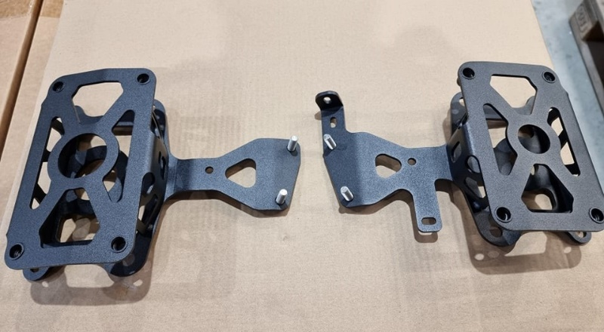

Install these brackets as shown below

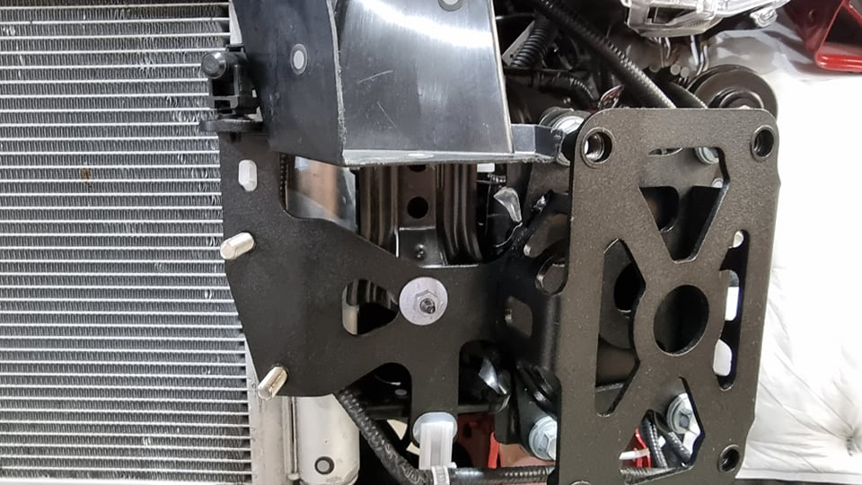

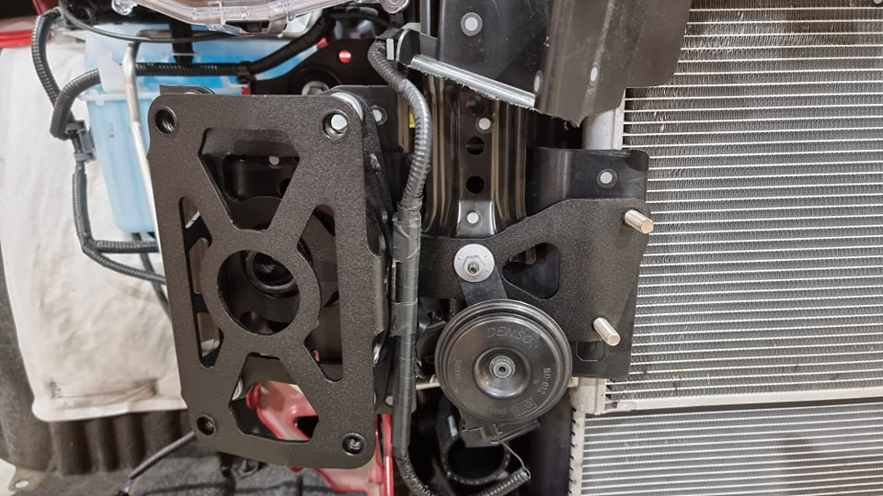

Note new horn mounting position

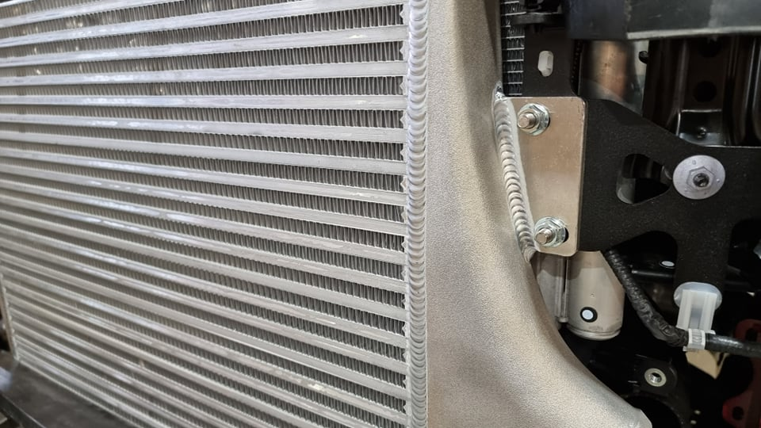
Install intercooler as shown.
Use supplied M8 nuts to secure.

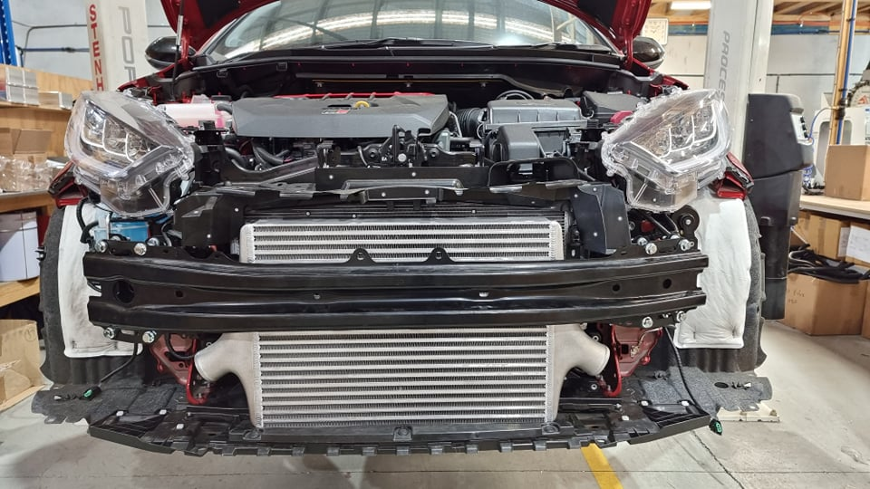
Reinstall crash bar. Use supplied M10
flange bolts.

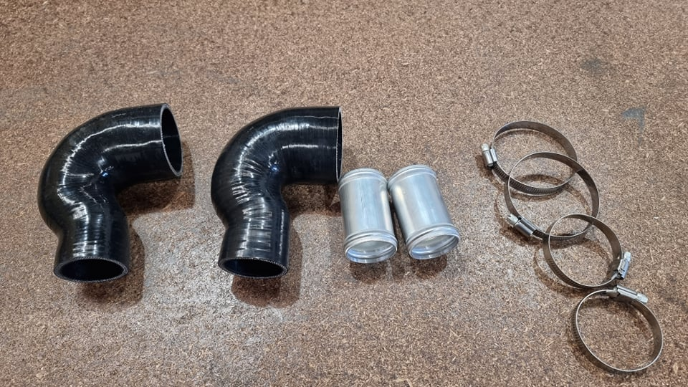
Locate these parts in you kit.

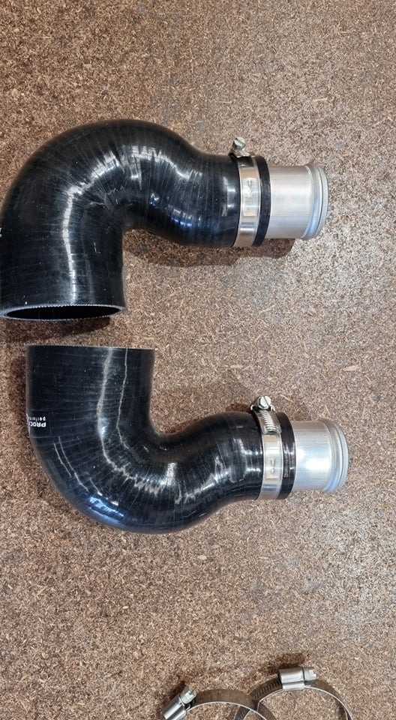

Assemble as shown.

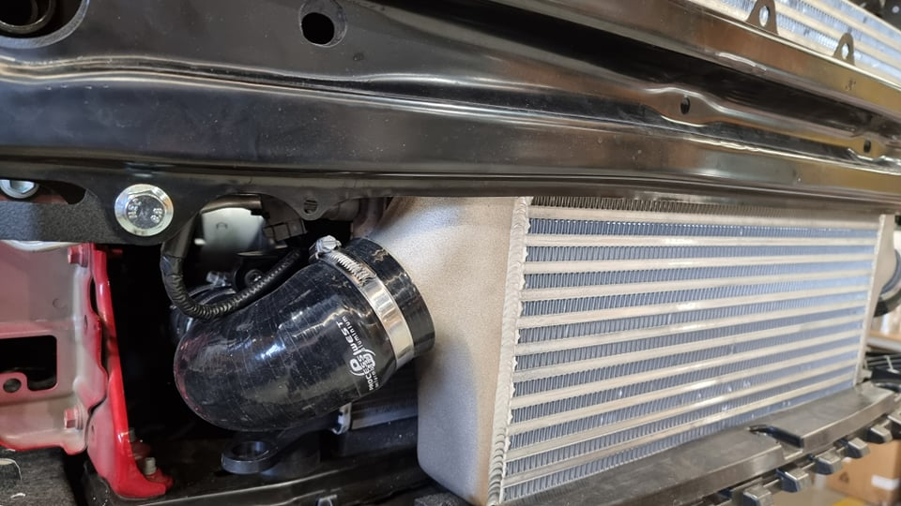

Install on both side of the
Intercooler as shown.

Re-install from bar. Job complete.

